# Changes BCA & SIPL Meeting (4th May 2017)

Booking Dashboard: <http://borgcivil.sipldemos.com/booking/dashboard-booking.php>

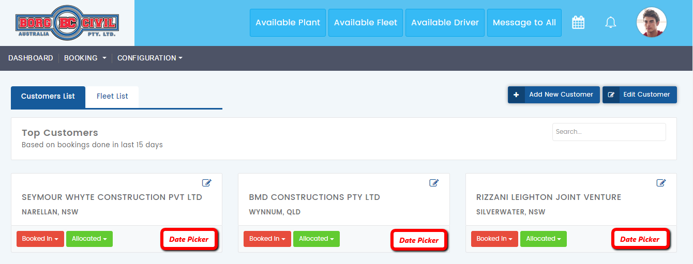

Change & Impacts: Client needs summary of fleets booked for each customer.

* We need to provide a date picker here with “Booked In & Allocated” dropdown, below will be the functionality of the button:
  + Once admin clicks on date picker, he will gets redirected to a page something like: <http://borgcivil.sipldemos.com/calendar/current-booking.php>
  + By default, “From & To” both date pickers will show today’s date
  + This list will show, list of booked-in & allocated fleets for the selected date for particular customer having data for all his sites
  + Columns will be same as: <http://borgcivil.sipldemos.com/booking/booking-work-allocation.php>
  + There will be a status column as well, and there will be only two types of status i.e. Booked-In or Allocated
  + Fleets in Booked-In status have same “Action” options as we are having in <http://borgcivil.sipldemos.com/booking/booking-work-allocation.php> (Booked-In Tab)
  + Fleets in Allocated status have same “Action” options as we are having in <http://borgcivil.sipldemos.com/booking/booking-work-allocation.php> (Allocated Tab)

Customer Dashboard: <http://borgcivil.sipldemos.com/customers/customer-dashboard.php>

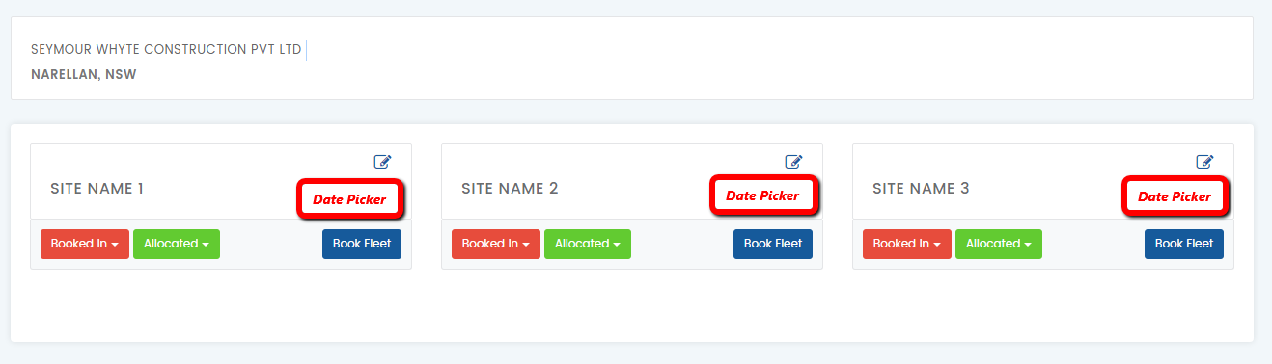

Change & Impacts: Client needs summary of fleets booked for each site.

* We need to provide a date picker here with “Booked In & Allocated” dropdown, below will be the functionality of the button:
  + Once admin clicks on date picker, he will gets redirected to a page something like: <http://borgcivil.sipldemos.com/calendar/current-booking.php>
  + On top customer name and site name will be shown
  + By default, “From & To” both date pickers will show today’s date
  + This list will show admin list of booked-in & allocated fleets for the selected date
  + Columns will be same as: <http://borgcivil.sipldemos.com/booking/booking-work-allocation.php>
  + There will be a status column as well, and there will be only two types of status i.e. Booked-In or Allocated
  + Fleets in Booked-In status have same “Action” options as we are having in <http://borgcivil.sipldemos.com/booking/booking-work-allocation.php> (Booked-In Tab)
  + Fleets in Allocated status have same “Action” options as we are having in <http://borgcivil.sipldemos.com/booking/booking-work-allocation.php> (Allocated Tab)

Book Fleet Popup: <http://borgcivil.sipldemos.com/customers/customer-dashboard.php>

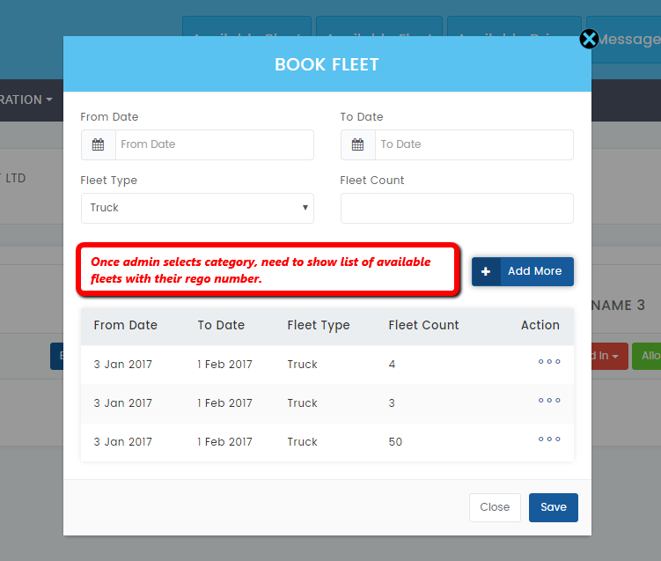

Change & Impacts: Client minimize the clicks and their efforts. At the time of booking they wants a quick look at available fleets also and select them directly from here.

* We will also need to capture below booking details, as all the selected fleets will come under a booking. By this way, it will be easy to track and create invoicing for booking:
  + Calling Date & Time
  + Booking Start Date
  + Booking End Date
  + Work Type
  + Notes
* As with the existing field, we need to add one more field i.e. combo checkbox. This will have list of fleets available w.r.t. selected category of fleet.
* Here fleet Rego number should be displayed, combo checkbox should be added so that admin can select multiple fleets.
* In this list, we also need to show available fleets of subcontractor. That can be differentiate with other colour or something else.
* Subcontractor name should be shown in bracket after fleet Rego number.
* Once admin clicks on “Add More” button, these details will be saved temporarily till he/ she clicks on “Save” button.
* Table beneath the form is correct, it will show list of fleets selected for particular category.
* Above change will make impact on Booked-In section as mentioned below:
  + All the details of the fleet with driver name will be populated in Booked-In section. There will be no SMS sent to driver of the selected fleet for now.
  + Above Booked-In list will be called as temporary booking.
  + Now admin goes for final allocation, he/ she clicks on allocation in action column.
  + Allocation pop will have prefilled information that admin selected in previous steps.
  + Here admin will select Gate Number, Supervisor, Contact Person, Work Type etc. and then clicks on Allocate button. This will put select fleet into Allocated state and SMS will be sent to selected driver.

*Client Notes:*

* *Tables should be same as shared in rough sketch for Booking Dashboard earlier.*
* *We should give option in Site registration, to select preferred fleet categories. And those selected categories will come on top as per the site selected from customer dashboard.*

Booking Dashboard-> Click on Site Name: <http://borgcivil.sipldemos.com/booking/work-allocation.php>

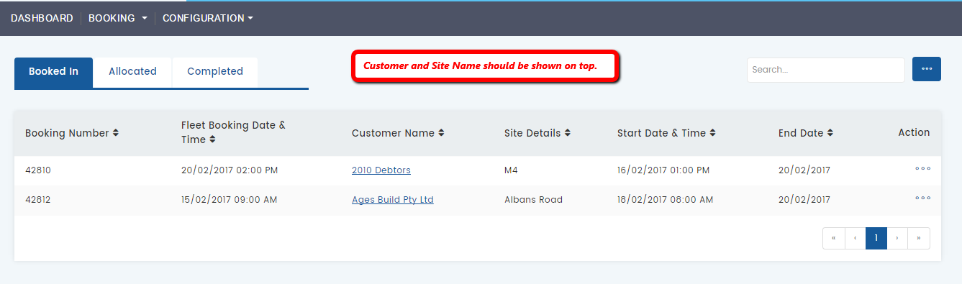

Change & Impacts: Customer and sites details should be shown on top.

Fleet Registration: <http://borgcivil.sipldemos.com/fleet/fleet-registration.php>

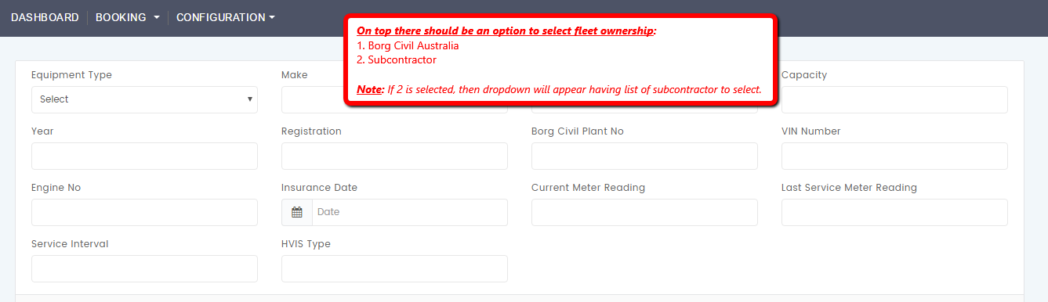

Change & Impacts: Need to create master for Subcontractor registration.

# Booking Module Changes After Meeting (27th April 2017)

Booking Dashboard:

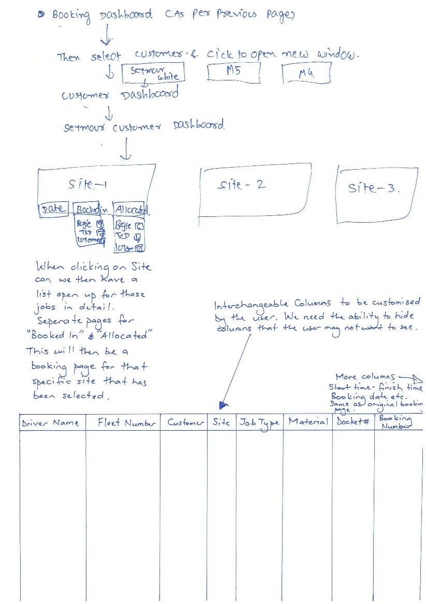

SIPL Understanding:

* We got the first 2 steps as mentioned below:
  + From booking dashboard admin will select customer
  + On new page, selected customer sites will be shown and this page will be termed as customer dashboard
* Site-1, will have below three buttons:
  + Date: Clicking on this button, a page will appear having below fields.
    - Date Picker: From Date & To Date
    - Dropdown to select fleet category
    - Textbox to enter number for fleets required for selected category
    - Book Fleets Button: Clicking on these 10 rows with selected fleet category will be created and will be shown in Booked In section

***Note:*** *There will also be a “Add More” button, clicking on it same above fields will appear. By this way admin can add multiple fleet categories.*

* + Booked In: We have to replace the below booked in table style and please change as we show on (page 1 under Booking Dashboard (Column wise (Driver Name, Fleet Number, Customer, site, Job type, Material, Docket Number, booking number, add more column as require)
    - Once admin clicks on this button new page will open, a table will be shown having list of fleets that needs to allocated.
    - On top fleet categories will be shown with respective number of fleets are in booked in state.
    - The columns will be same as currently we are having in booking form. Please check below screenshot for the same.

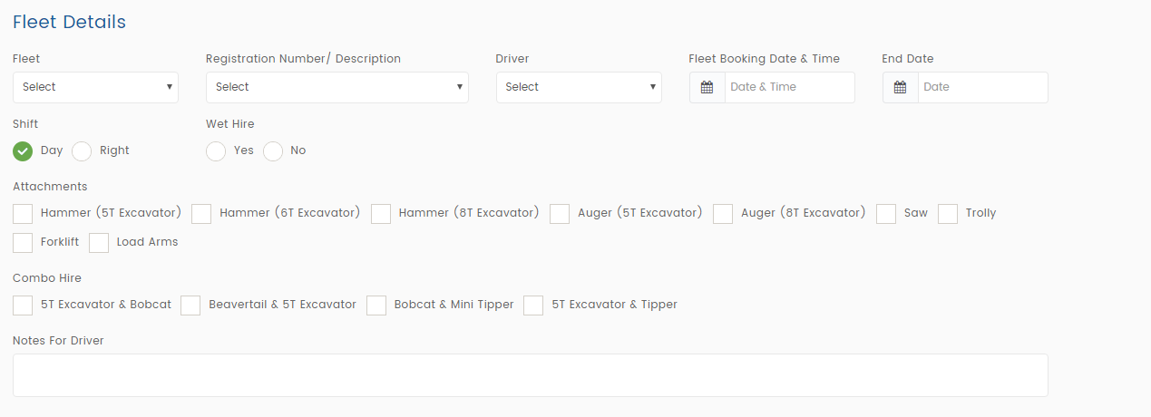

* + - There will be an option to allocate, once admin ticks on allocate then selected fleet will go into allocation section. A SMS will be sent to driver with all the details.
  + Allocated
    - Once admin clicks on this button new page will open, a table will be shown having list of fleets that needs to allocated.
    - On top fleet categories will be shown with respective number of fleets are in allocated state.

***Note:*** *For now, we will not be able to provide interchangeable columns, hide feature & right click option. Once our core features are completed then we will estimate efforts for the same and share with you. Then after your approval, will work on it.*

Allocated List of Fleets:

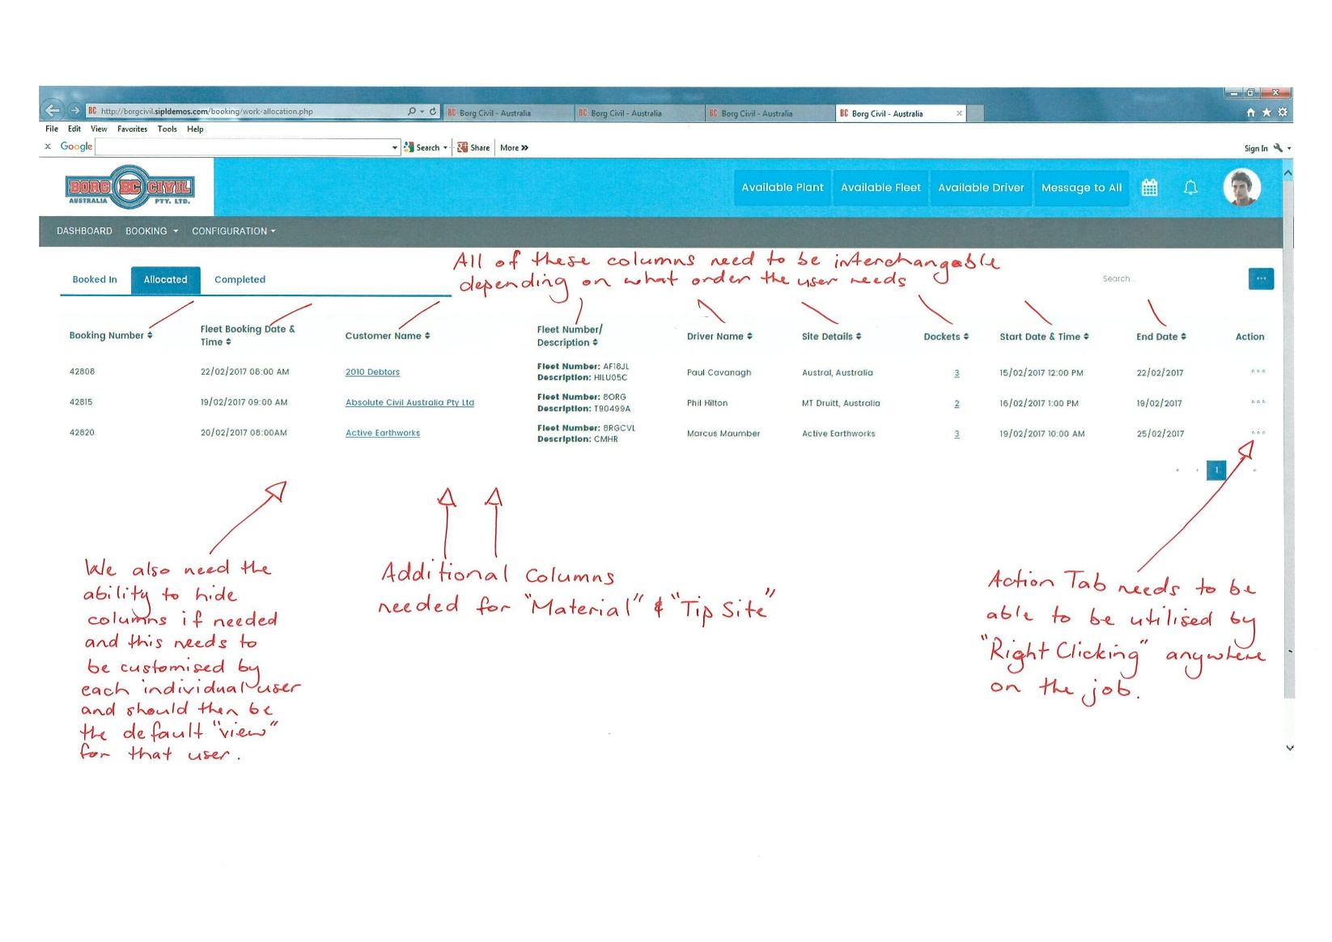

SIPL Understanding:

* Okay we will add columns – Material & Tip Site.

***Note:*** *For now, we will not be able to provide interchangeable columns and hide feature. Once our core features are completed then we will estimate efforts for the same and share with you. Then after your approval, will work on it.*

SIPL Queries:

* Please share us, where we need to add Material & Tip Site in booking form? So that we can show it here in the list.

Existing Job Booking Form (General Details):

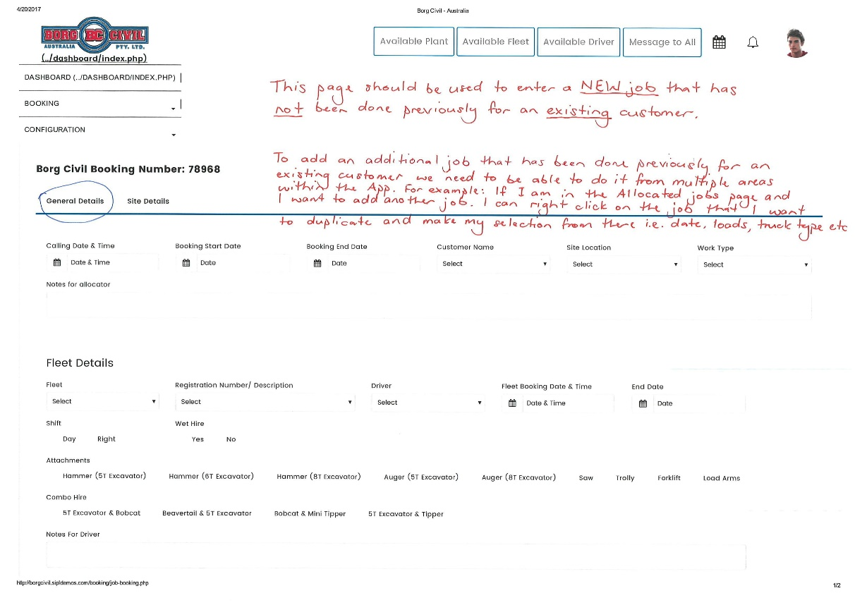

SIPL Understanding:

* Yes, we will keep this form also with the booking from customer dashboard.

SIPL Queries:

* Can you please put some more light on duplicate booking? ***So, if there is a job already booked In, allocated or even completed, we need to be able to just right click on that job and have the ability duplicate it. As in add another job exactly the same as the last.***

Existing Job Booking Form (Site Details):

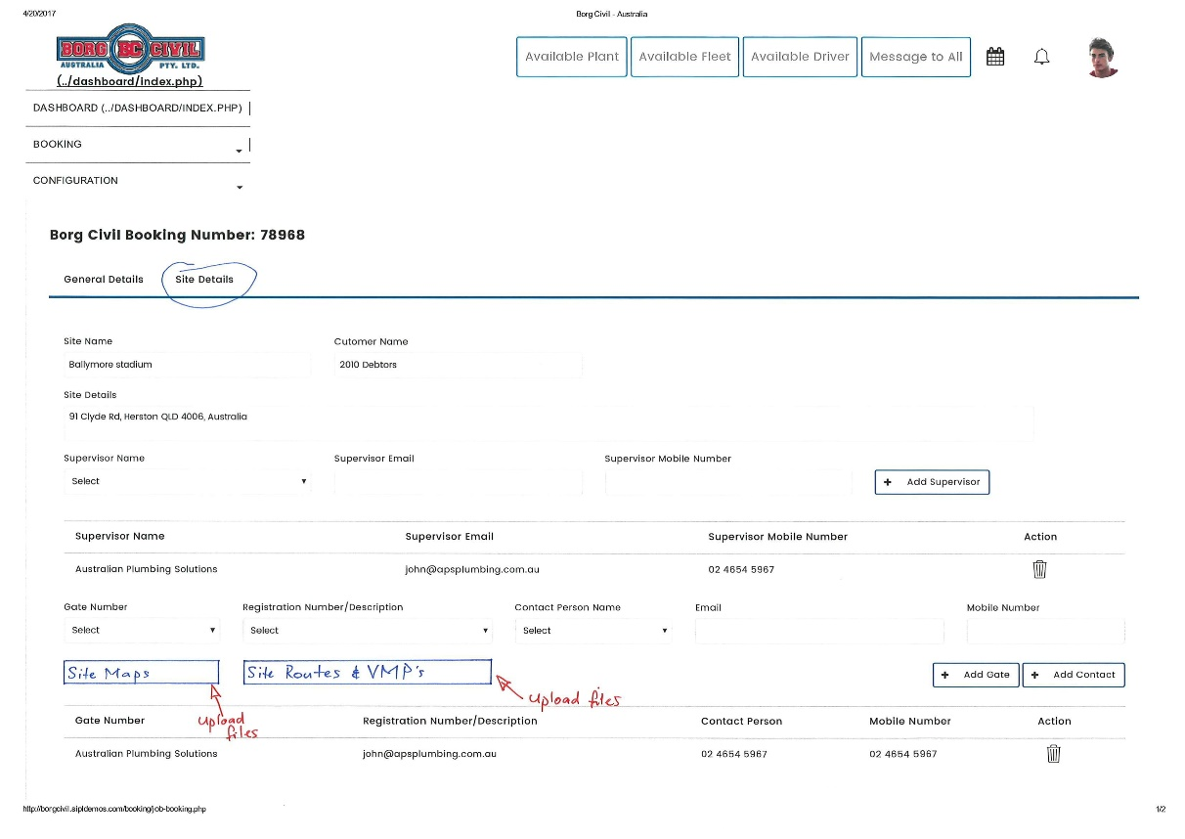

SIPL Understanding:

* Sure, we will provide option to upload Site Maps & Site Routes. (Multiple file uploader)

On Booking page-> Site details, we want to have ability to upload files to capture the site location on google map. My questions are following:

a. Why does admin need to capture the map? Who is going to use this information?

b. Because if I understand correctly, Drive only gets SMS about the booking, so this files cannot be accessed by him.

c. Invoicing team is not concerned about the location as long as the rates are provided.

d. In my opinion this will further increase time taken to book a job.

Work Allocation:

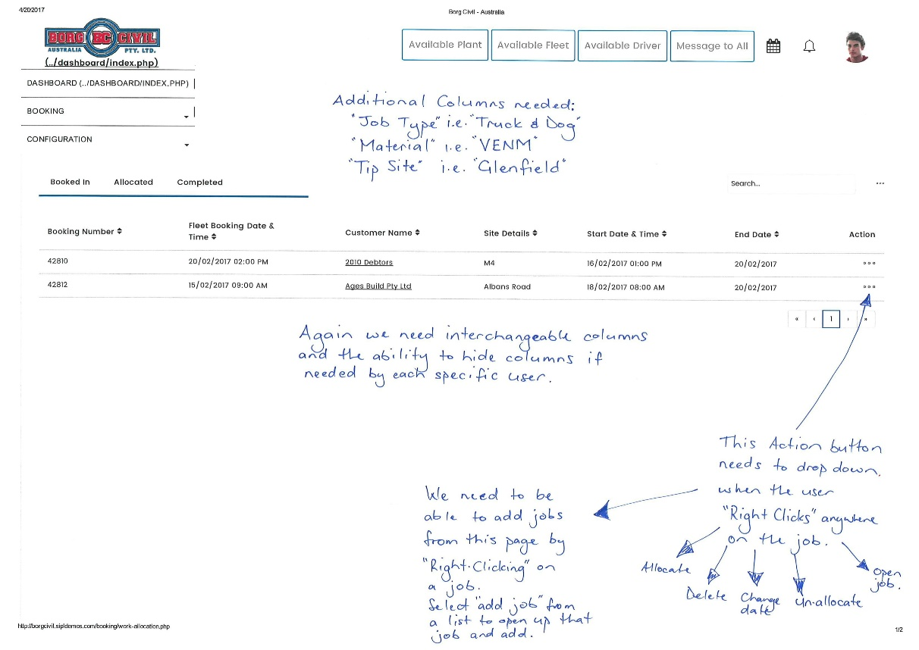

SIPL Understanding:

* Sure, we will add new columns. Please share us, where we can add Material & Tip site on job booking form.
* Clicking on Open Job, admin can add more fleets into existing job. Please let us know, if you have any different views for the same.

***Note:*** *For now, we will not be able to provide interchangeable columns and hide feature. Once our core features are completed then we will estimate efforts for the same and share with you. Then after your approval, will work on it.*

Booking List:

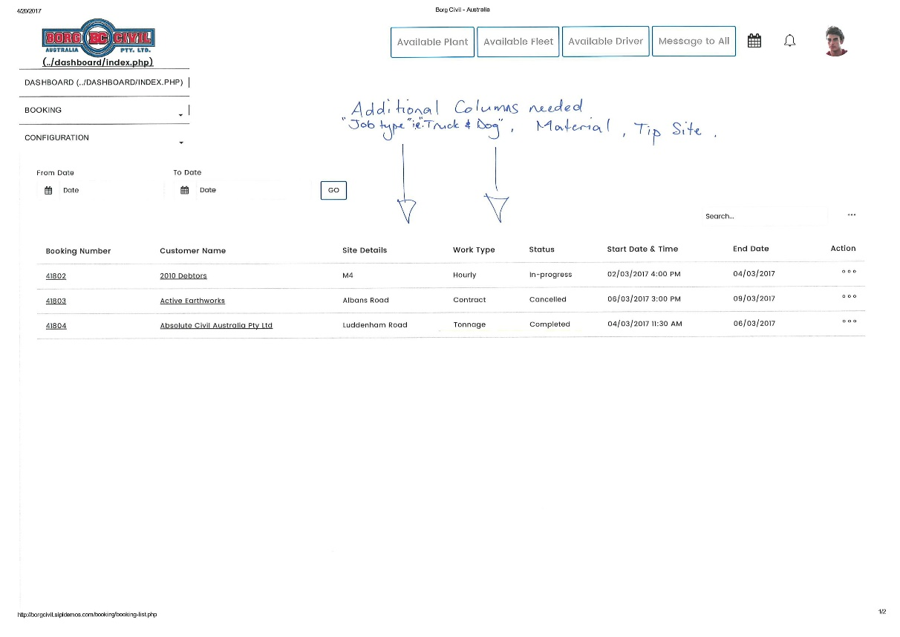

SIPL Understanding:

* Sure, we will add new columns. Please share us, where we can add Material & Tip site on job booking form.